AYUSH A POLADIYA

GREEN COMPUTING

ROLLNO:-2317046

Toxicity: Let’s Detox Toxins

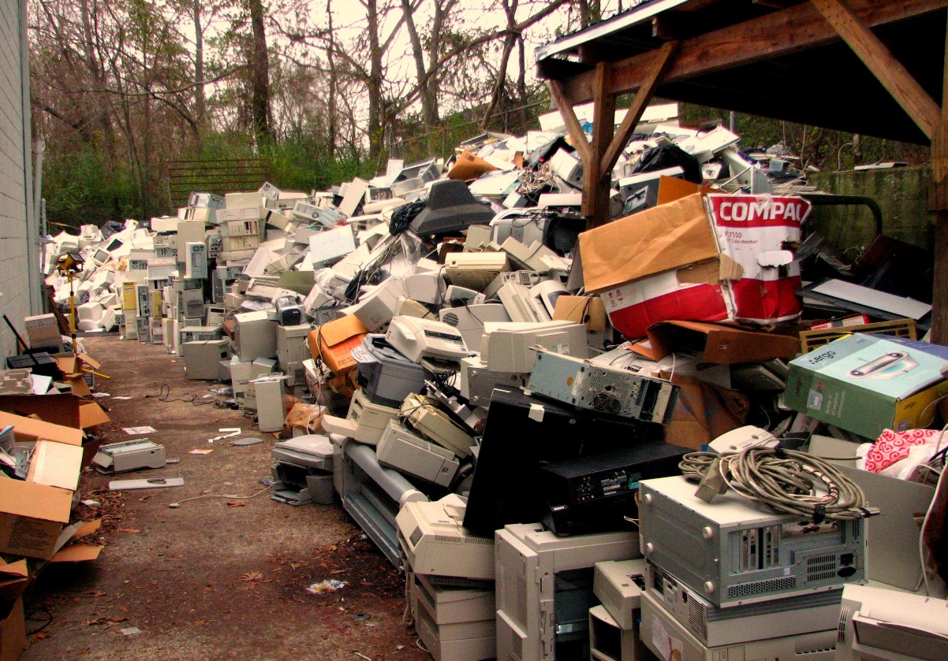

**TABLE OF CONTENT**

|  |  |  |
| --- | --- | --- |
| Sr.no | Table Of Content | Pageno |
| 1 | Synopsis | 3 |
| 2 | Chapter 1: Introduction | 4-15 |
| 3 | Chapter 2: Review Of Literature | 16-25 |
| 4 | Chapter 3: Prototype Model and Implementation | 26-31 |
| 5 | Chapter 4: Results and Discussions | 32-35 |
| 6 | Chapter 5: Future Enhancement and Conclusion | 36-37 |
| 7 | Chapter 6: Bibliography | 38-40 |

Acknowledgement

In accomplishment of this project successfully many of them have

being part with their bunch of blessing. Primarily, we would thank

God for being able to complete the project tested successfully, then

we would thank my Green Computing teacher Dr. Priti Pathak

whose valuable guidance has been done ones that helped us for

this project in terms of her instruction, examples. Then I would also

extend my gratitude, to The Principal Dr. Sonali Pednekar and head

of department (B.Sc. (IT)) Dr. Hiren Dand for providing opportunity

to show our work in the crowd of growing talent. It is pleasure were

we got this opportunity to embark on this project with immense

support of our parents and friends. At last, but not least gratitude

goes to all of my friends who directly or indirectly helped me to

complete this project report.

**Title of the project: -Toxicity: Lets Detox the Toxins**

**Members of the project**: -

* Name: -Ayush.A. Poladiya
* Roll no: - 2317046

**Purpose of the project: -**

1) Environmental Protection

2) Human Health

3) Sustainable Technology

4) Resource Conservation

5) Awareness and Education

**Bibliography: -**

* Green IT By Toby VeLte, Anthony Velte and Robert Elsenpeter
* Green Technology

Chapter 1: -INTRODUCTION

A. GENERAL INTRODUCTION

Green computing, also referred to as GREEN IT, is the practice of utilizing, producing, and disposing of computing resources in a manner that is eco-friendly. The objective of green computing is to increase sustainability while minimizing the damage that computers cause to the environment.

Computing resources such as computers, servers, and data centers consume a

significant amount of energy and contribute to environmental problems such a

electronic waste and greenhouse gas emissions. To reduce the environmental

impact of computing, green computing employs energy-efficient technology,

promotes sustainable behavior in the use of computing resources, and reduces

electronic waste through recycling and safe disposal.

As computing technology becomes more widespread in society, the importance of green computing is growing. Governments, businesses, and individuals all

recognize the need to reduce their environmental impact, and green computing is one way to achieve that goal. Examples of green computing practices include virtualization, cloud computing, and energy-efficient hardware.

Green computing shares similar goals with green chemistry, such as reducing the

use of hazardous materials, maximizing energy efficiency during the product's

lifespan, and improving the recyclability or biodegradability of waste. Green

computing is critical for all types of systems, from handheld devices to large-scale

data centers. Many corporate IT departments have green computing initiatives to

minimize the environmental impact of their IT operations. However, it is also

evident that the sector's environmental footprint is significant, accounting for an

estimated 5-9% of the world's total electricity usage and more than 2% all of emission



* *Description of the project*

Nowadays computers are used on huge scales worldwide. Use these devices may be in the form of Desktop, Laptop and Mobile phones. As these all are electronic devices and runs on electric power and batteries, it causes harm to an environment directly as well as indirectly. In all of this Major problem is cause by the electronic waste specially in IT sector.

Electronic waste, or e-waste, refers to all items of electrical and electronic equipment

(EEE) and its parts that have been discarded by its owner as waste without the intent of re-use (Step Initiative 2014). E-waste is also referred to as WEEE (Waste Electrical and Electronic Equipment), electronic waste or e-scrap in different regions and under

different circumstances in the world.

Electronic waste (e-waste) in the IT sector can include a wide range of electronic

equipment, such as:

* 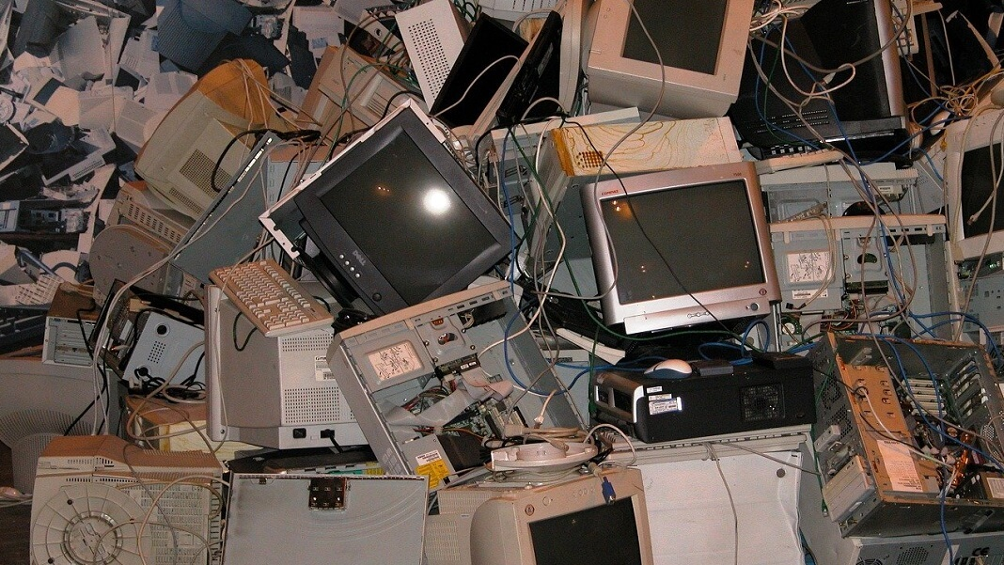Computers: Desktops, laptops, servers, and Keyboards and mouse Speakers and headphones Webcams and microphones External hard drives and USB drives Monitors and projectors Scanners and printers Graphics table sand pens Docking stations and USB

hubs CD/DVD drives and media players

Network interface cards and adapters.

* Communication equipment: Phones, routers, modems, and switches.
* Office equipment: Printers, copiers, and fax machines.
* Medical equipment: Imaging machines, monitors, and diagnostic equipment.
* Industrial equipment: Control systems, sensors, and other electronic

components.

* Batteries: Rechargeable batteries used in laptops, phones, and other electronic

devices.

* Cables and cords: Various cables and cords that connect electronic devices.

In India electronic waste is emerging as a serious public health and environmental issue

in India. India is the "Third largest electronic waste producer in the world";

approximately 2 million tons of e-waste are generated annually and an undisclosed

amount of e-waste is imported from other countries around the world.

Annually, computer devices account for nearly 70% of e-waste, 12% comes from the

telecom sector, 8% from

medical equipment and 7%

from electric equipment. The

government, public sector

companies, and private sector

companies generate nearly

75% of electronic waste, with

the contribution of individual

household being only 16%.

E-waste is a popular, informal

name for electronic products

nearing the end of their "useful life." Computers, televisions, VCRs, stereos, copiers,

and fax machines are common electronic products. Many of these products can be

reused, refurbished, or recycled. There is an upgradation done to this E-waste garbage list which includes gadgets like smartphone, tablets, laptops, video game consoles, cameras and many more. India had 1.012 billion active mobile connections in January2018. Every year the number is growing exponentially According to ASSOCHAM, an industrial body in India the, Compound Annual Growth Rate of electronic waste is 30%. With changing consumer behavior and rapid economic growth, ASSOCHAM estimates that India will generate 5.2 million tons of e-waste by 2020.While e-waste recycling is a source of income for many people in India, it also poses numerous health and environmental risks. More than 95% of India's e-waste is illegally recycled by informal waste pickers called kabaddiwalas or raddiwalas which is “Junk Dealer” and “Scrap Dealer ". These workers operate independently, outside of any formal organization which makes enforcing e-waste regulations difficult-to-impossible.

Recyclers often rely on rudimentary recycling techniques that can release toxic

pollutants into the surrounding area. The release of toxic pollutants associated with

crude e-waste recycling can have far reaching, irreversible consequences.

Along with mentioned issues above there are many other issues related with these

electronic equipment's. Green computing

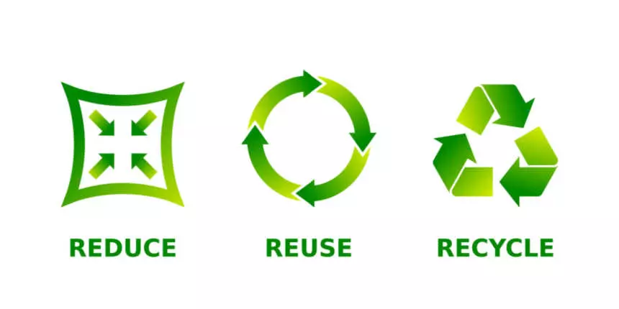addresses these issues with the words

"Reduce, Reuse, Recycle".

Reduce: We should limit the number of

purchases that we make in the first

place. So, for example, we might limit our

household to a single computer.

REDUCE: Reducing toxins refers to the process of minimizing or eliminating harmful

substances, often chemical or biological in nature, that can have detrimental effects on living organisms and the environment. This can involve various strategies, such as pollution control measures, detoxification processes, or lifestyle changes, aimed at decreasing exposure to toxins and promoting overall well-being and environmental sustainability.

Reuse: We should reuse items as much as possible before replacing them.

For example, it generally makes more environmental sense to update our computer rather than get rid of it and buy a new one. However, if we replace our computer, we should ensure that it, or its components, is reused. Many charitable organizations welcome donations of second-hand computers.

Recycle: We should ensure that items or their components are put to some new purpose as much as possible. If our computer is not fit for reuse as is, we can donate it to one of serval org which will refurbish it or recycle the components.

The Project is made by me is too aware the people about the toxins substance that is released from the computer’ and computer related products like keyboards, CPU’s, etc.

What is E-waste? Electronic waste or e-waste is the term used to describe old, end-of-life electronic appliances such as computers, laptops, TVs, DVD players, mobile phones, mp3 players, etc., which have been disposed by their original users. E-waste has been categorized into three main categories, i.e., Large Household Appliances, IT and Telecom and Consumer Equipment. Refrigerator and washing machine represent large household appliances; PC, monitor and laptop represent IT and Telecom, while TV represents Consumer Equipment. What are Toxic Substances? Toxic substances are the hazardous substances which are released from the electronic waste and ability of a substance to cause harm to the environment and living beings is known as Toxicity.

The main sources of computer usage and thereby e-waste generations are the business sector (government departments, public or private sector, multinational corporation offices, etc.), accounting for 78% of the total installed PCs today. Other sources are individual households (22%), foreign embassies, PC manufacturing units, PC retailers, secondary markets of old PCs and imported electronic scrap of other countries.

The following three categories of WEEE account for almost 90% of the generation

: · Large household appliances: 42%

· Information and communications technology equipment: 33.9 %

· Consumer electronics: 13.7%

The composition of WEEE/e-waste is very diverse and differs in products across different categories. It contains more than 1000 different substances, which fall under ‘hazardous’ and ‘non-hazardous’ categories. Broadly, it consists of ferrous and nonferrous metals, plastics, glass, wood and plywood, printed circuit boards, concrete and ceramics, rubber and other items. Iron and steel constitute about 50% of the WEEE followed by plastics (21%), non-ferrous metals (13%) and other constituents. Nonferrous metals consist of metals like copper, aluminium and precious metals, e.g., silver, gold, platinum, palladium, etc. The presence of elements like lead, mercury, arsenic, cadmium, selenium and hexavalent chromium and flame retardants beyond threshold quantities in WEEE/e-waste classifies them as hazardous waste.

The electronic and electrical goods are largely classified under three major heads, as: ‘white goods,’ comprising of household appliances like air conditioners, dishwashers, refrigerators and washing machines; ‘brown goods,’ comprising of TVs, camcorders, cameras, etc.; ‘grey goods,’ like computers, printers, fax machines, scanners, etc. The grey goods are comparatively more complex to recycle due to their toxic comp



Sources of E-Waste: Any appliance that runs on electricity has the potential to cause damage to the environment if it is not disposed properly. Common things of electrical and electronic waste are:

· Large household appliances like refrigerators/freezers, washing machines, dishwashers, televisions.

· Small household appliances which include toasters, coffee makers, irons, hairdryers.

· Information Technology (IT) and Telecommunications equipment namely personal computers, telephones, mobile phones, laptops, printers, scanners, photocopiers etc

. · Lighting equipment such as fluorescent lamps.

· Electronic or Electrical tools i.e., handheld drills, saws, screwdrivers etc

. · Toys, leisure and sports equipment.

· Monitoring and control instruments.

· Automatic dispensers.

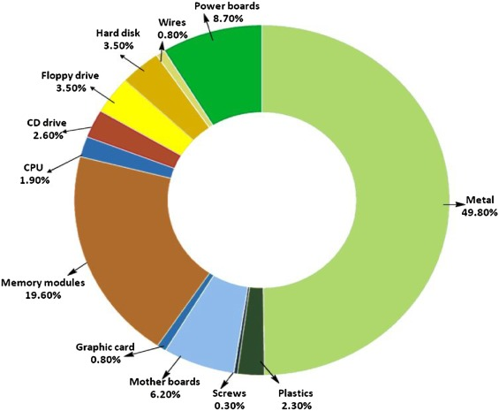Composition of E-waste

: Composition of E-Waste includes materials like:

· Valuable metals like gold, platinum, silver and palladium

. · Useful metals like copper, aluminium, iron etc.

· Hazardous substances like radioactive isotopes and mercury

. · Toxic substances like PCB’s and Dioxins.

· Plastic like High Impact Polystyrene (HIPS), Acrylonitrile Butadiene Styrene (ABS), Polycarbonate (PC), Polyphenylene oxide (PPO) etc.

· Glass material like Cathode Ray Tube glass made up of SiO2, Cao, Na. For instance, a mobile phone contains more than 40 elements, base metals such as Copper (Cu) and Tin (Sn), special metals such as Lithium (Li), Cobalt (Co), Indium (In) and Antimony (Sb) and precious metals such as Silver (Ag), Gold (Au), and Palladium (Pd).

Harmful Effects OF Toxins ON Human Health: -

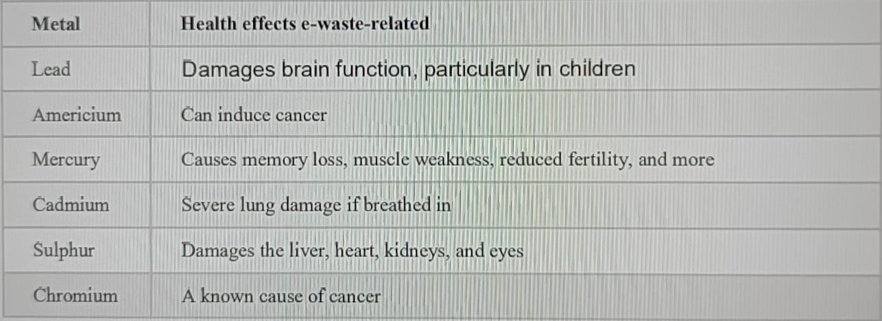

· One cell phone contains up to 2 grams of mercury.

· Mercury is highly poisonous, affecting the brain, digestive system, reproductive system, kidneys and liver.

· These e-waste diseases can be caused by inhaling, eating, drinking very small amounts of mercury, or skin contact

. · When e-waste is incinerated, the air is filled with tiny and invisible mercury atoms that are easily inhaled then absorbed by the body.

Environmental protection hierarchy: (including 3R mantras)

Waste hierarchy is a tool used in the evaluation of processes that protect the environment alongside resource and energy consumption from most favourable to least favourable actions. The hierarchy establishes preferred program priorities based on sustainability.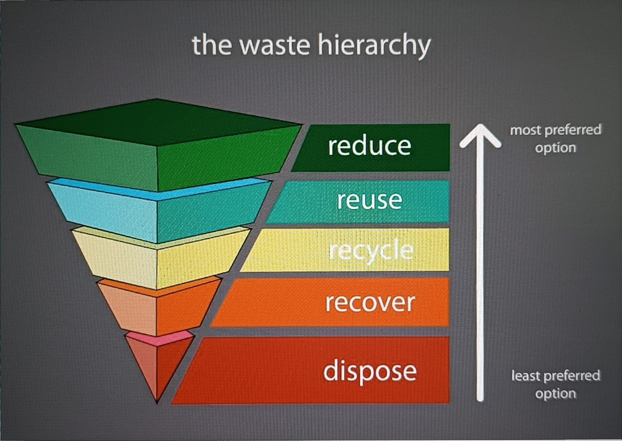 1. REDUCE: Using fewer resources helps in reducing their consumptions. For example, minimizing the use of e-waste generating products thereby using green resources

REUSE: Using things again rather than throwing them after using only once. For example, reusing of computer parts even after disposing it off. Old working computers can be donated to schools or organization working in the field of education. Computers beyond repairs can be returned back to the manufacturers. This can considerably reduce the volume of E-Waste generation converted into less hazardous compounds

RECYCLE: The process which substances which are used before are put back into process to make new items. For example, used and discarded plastic, metals, etc can be used to make bags, etc.

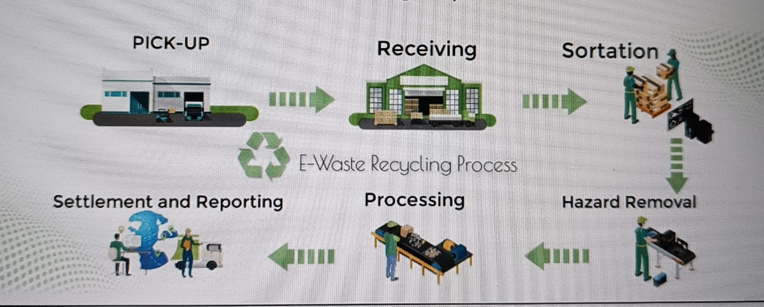

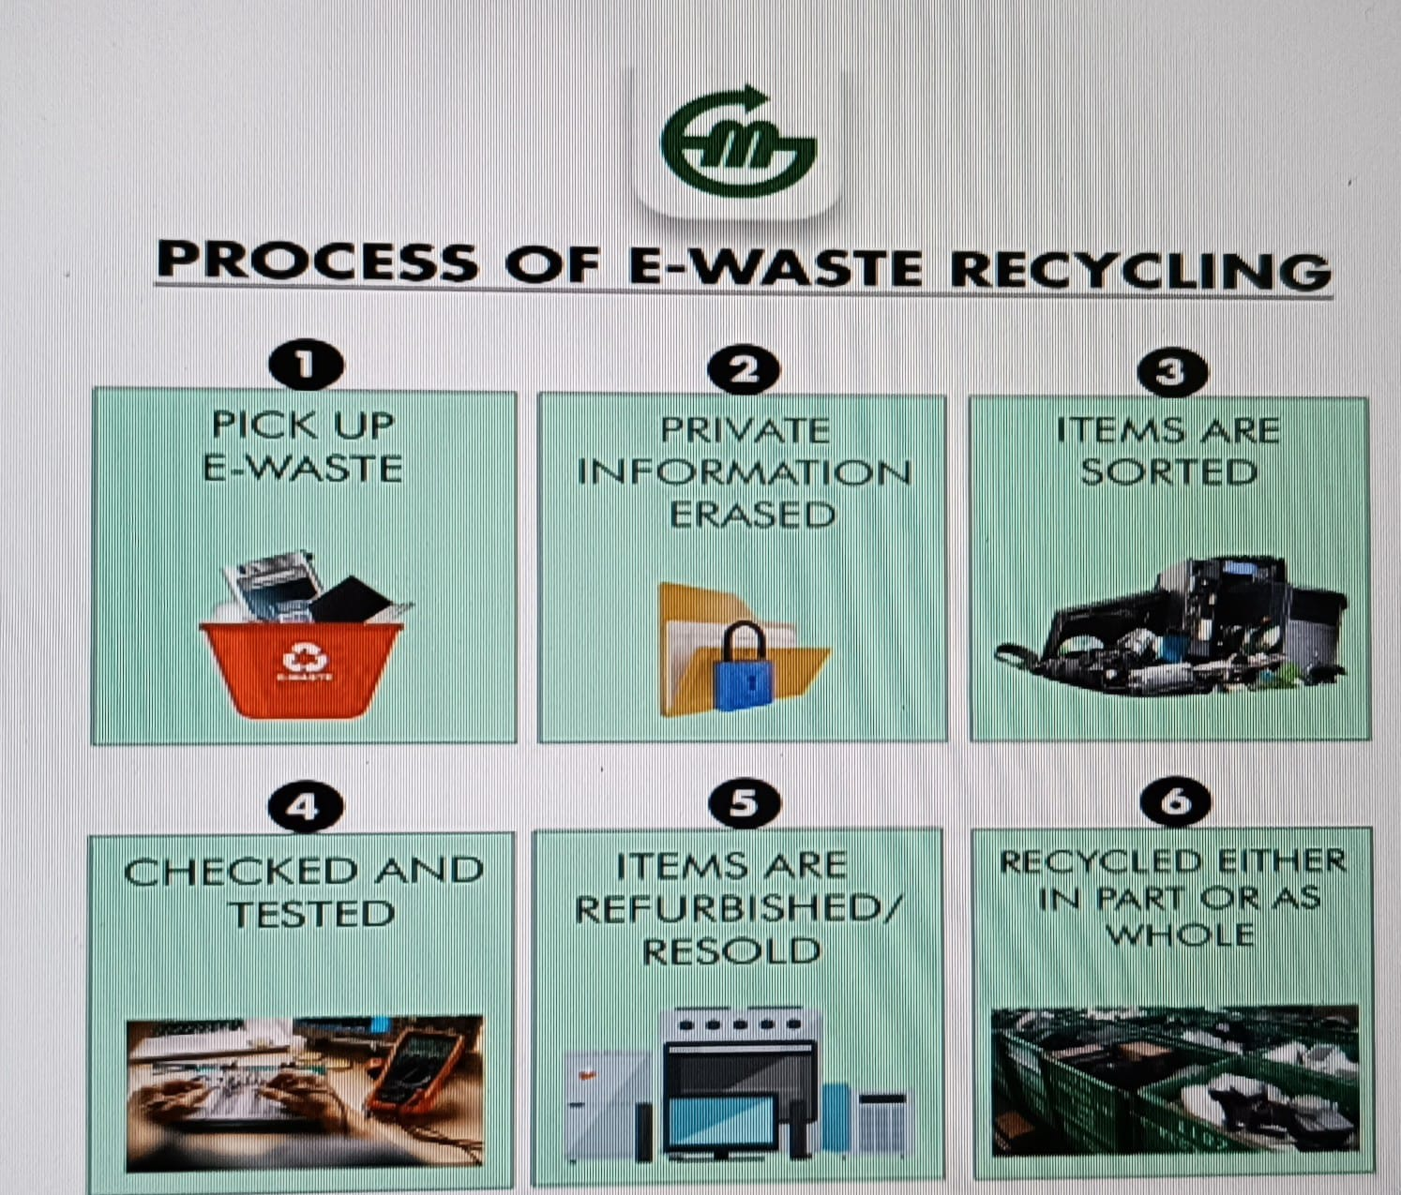

RECOVER: The recovery of metals and other materials from waste electric and electronic equipment represents a major opportunity that relates both to their high value and their re-use in hi-tech components and products. The demand for such materials has remarkably increased in recent years, thus giving rise to critical issues related to their supply, particularly because their availability is both limited and conditioned by the monopoly held by primary producers

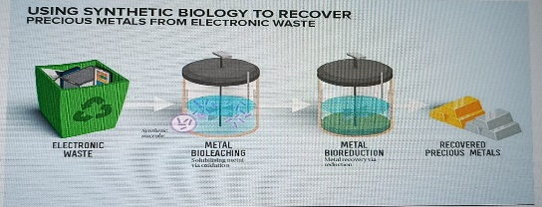

4. DISPOSE:

#1 Give Your Electronic Waste to a Certified E-Waste Recycler The positive aspect of e-waste recycling is that you have quite a few recycling options. You need to find an e-waste recycler who is officially certified by the Basel Action Network (BAN). BAN is a non-profit organization of recycling companies which are dedicated to recycling e-waste in a safe and responsible way. All members have to make a pledge and display their Pledges of Responsible Recycling. So working alongside a certified recycler means that you don’t have to worry about polluting another nation or risk losing your personal details to criminals.

#2 Sell Off Your Outdated Technology One man’s junk is another man’s treasure as the old saying goes. This can be applied to helping you get rid of your old electronics. You can tap into online sites like craigslist, eBay or even resort to having a garage sale as this will help you get rid of your outdated electronics as well as earning some money.

#3 Donating Your Outdated Technology Old gadgets that you no longer need can be donated as they may be useful to others. Your old computer may be useful to either an NGO or students. You should ask yourself these 2 questions before disposing of your old electronics:

§ Is the electronic item working?

§ Does the computer have any of your personal information?

A lot of organizations and businesses offer electronic donation programs which you can chose from

#4 Visit Civic Institutions Enquire amongst your government, universities, and schools for any recycling programs they run as a lot of organizations have started assigning a certain day and place for environmentally conscious citizens to come and drop off their e-waste.

#5 Give Back to Your Electronic to Companies and Drop Off Points A lot of electronic companies tend to have an exchange policy whereby they take back your old gadgets when you buy a later version, sometimes offering you a discount on your new purchase. A few recycling companies have set up electronic drop off initiatives along with drop off points for products such as cell phones and tablets after which they are recycled. You can ask your local electronics shops regarding any information about drop off locations.

Do’s

· Always look in the Product Catalogue for information on end-of-life equipment handling.

· Ensure that only Authorized Recyclers/Dismantler handle your electronic (i.e., bar code scanners, bar code printers, mobile computers, and their components) products

· Always drop your used electronics, products, batteries, or any accessories when they reach the end of their life at your nearest authorized e-waste collection points

. · Always disconnect the battery from the product and ensure any glass surface is protected against breakage.

Don’ts

· Do not dismantle your electronic products on your own.

· Do not throw electronics in bin.

· Do not give e-waste to informal and unorganized sectors like Local Scrap Dealer/ Rag Pickers.

· Do not dispose of your product in garbage bins along with municipal waste that ultimately reaches landfills

CHP:2 REVIEW OF LITREATURE

Khalid Raza et al.,2012 [9] In their research work they discuss about The

manufacturing of electronic components and computers consumes energy, raw

materials, chemicals, and generates hazardous waste, leading to increased

carbon dioxide emissions. Human activities are altering the carbon cycle by adding

more CO2 to the atmosphere, leading to global warming and climate change. The

imbalance in the composition of air can cause disastrous consequences like rising

sea levels, droughts, floods, and extreme weather conditions. Information and

communication technology (ICT) is contributing to environmental problems such

as global warming and climate change, and it is predicted to increase. Green

computing has emerged as an initiative for eco-friendly and sustainable IT. The

industries worldwide need to review their environmental credentials to address the

issue of global warming and climate change.

Govind Mishra and Venkat Ramanan, 2014 [6] the main focus is on the Green

computing is about making computers in an environmentally friendly way, from

start to finish. Carbon dioxide and other emissions from computers are hurting the

environment, so it's important to reduce them. Researchers are finding ways to

make computers that don't harm the environment, like using non-toxic materials

and making them energy efficient. This is important because energy costs are

going up and we need to reduce greenhouse gas emissions. A study predicts that

the internet industry could produce a lot of greenhouse gases, but we can use

smart technology to reduce them. It's really important to take care of the

environment, and we can do that by making computers in a better way.

Cengiz Taplamacioglu, 2015 [4] the author states that Accurate electricity

consumption forecasting is crucial for energy planning in developing countries.

Support vector machines (SVMs) and least squares support vector machines (LS-

SVMs) are being used for energy consumption forecasting. This study uses LS-

SVM to predict Turkey's electricity energy consumption, with traditional regression

analysis and artificial neural networks (ANNs) also considered. Historical data from

1970 to 2009, including gross electricity generation, installed capacity, total

subscribership, and population, are used as independent variables. Forecasting

results are compared using diverse performance criteria, with ROC analysis used

to determine the specificity and sensitivity of empirical results. The study concludes

that the proposed LS-SVM model is an accurate and quick prediction method for

electricity consumption forecasting.

Peeranart Kiddee et al., 2013[13] They summarize that e-waste is one of the fastest-growing pollution problems worldwide due to its toxic substances and potential environmental and human health impacts. Management strategies include eco-design devices, properly collect and recycle material, dispose of e-waste by suitable techniques, forbid the transfer of used electronic devices to developing countries, and raise awareness of the impact. E-waste is a growing problem due to consumer technology changing and rapid obsolescence, resulting in massive amounts of e-waste. It consists of many different materials, some of which contain toxic substances that can contaminate the environment. E-waste is a large variety of materials that contain toxic substances that can contaminate the environment and threaten human health. There is inadequate legislation worldwide for effective management of such waste, leading to inappropriate management strategies in both developed and developing countries. E-waste disposal methods include landfill and incineration, both of which pose considerable contamination risks. Management of e-waste by recycling and by disposal to landfills has been shown to pose significant risks to the environment.

Sivasankari et al., 2015[18] Author discusses the concept of green computing, which is an effective approach to protect the environment from hazardous materials and their impacts that arise from computers and electronic devices. The paragraph highlights the importance of green computing as a study of environmental science that emphasizes the manufacturing, usage, disposal, and recycling of electronic devices. Then describes a research paper that focuses on the need for green computing an steps that can be taken by the common man to promote it. The paper emphasizes that computers have become a basic necessity in today's world, and no individual or organization can function without them. However, the manufacturing and disposal of these devices can have harmful impacts on the environment. Overall, he presents a clear and concise overview of the concept of green computing, its importance, and the steps that can be taken to promote it. It highlights the significance of adopting a more sustainable approach to the manufacturing and disposal of electronic devices, which is essential for protecting the environment and ensuring a sustainable future. The paragraph could benefit from providing more specific examples of the harmful impacts of electronic devices on the environment and how green computing can help mitigate these impacts.

Krati Banal et al., 2015[10] The author mentions the increasing levels of greenhouse gases in our environment and how the use of computers and electronic gadgets by consumers is contributing to this issue. It emphasizes the need for awareness about the harmful impacts of these technologies on the environment and introduces the concept of green computing as a solution to this problem. The main objective of green computing is to minimize the negative effects caused by the use of technology and promote environmental sustainability while also driving business growth. The paragraph also mentions the various initiatives taken and research issues that need to be addressed to make green computing a success. It highlights the importance of awareness and education about green computing among consumers and the challenges that need to be overcome to achieve this goal. Overall, the author provides an informative and thought-provoking introduction to the concept of green computing and its significance in promoting a healthier and sustainable environment. It prompts readers to consider their own use of technology and the impact it has on the environment, and encourages them to take action to promote eco-friendly computing practices.

Santosh Kumar, 2015[16] Author says the importance of green computing, which refers to the use of energy-efficient and eco-friendly computing resources. It sheds light on the fact that environmental organizations and businesses from various industries are focusing on this aspect to reduce their carbon footprint. The paragraph also indicates that the computer industry has recognized the significance of going green and has initiated various green initiatives to cut down costs and enhance their public image. The author also discusses some issues that have been raised concerning these initiatives. It presents a study as an example to explore the future of green computing. The paragraph, overall, is informative and provides an excellent introduction to the concept of green computing, its significance, and its adoption by the computer industry. However, it lacks specific details about the initiatives and issues raised, which could be useful for readers looking for more comprehensive information. Nonetheless, the paragraph is well-written, and the topic is crucial for the sustainable development of our planet.

Veenaa Deeve et al., 2015[20] Author highlights the recent and significant research field of green computing, which focuses on finding ways to use energy efficiently. The researchers primarily concentrate on two aspects of green computing: energy efficiency and power consumption and making green software to thrive the industry and create innovative products. However, the transition from traditional computing to green computing poses several challenges. Despite these challenges, successful implementation of green computing can significantly contribute to environmental development and safety. The paragraph further mentions that top companies are increasingly taking the migration towards green computing seriously. Author provides an excellent overview of green computing, which is a crucial aspect of sustainable development in today's world. The paragraph highlights the importance of energy efficiency and power consumption in the computing industry and how the shift towards green computing can help address these issues. It also mentions the importance of creating green software to promote innovative products. However, the paragraph could have provided more details about the challenges faced during the transition and how companies are tackling them. Additionally, the paragraph could have mentioned some specific examples of successful implementation of green computing by companies to give readers a better idea of its potential benefits. Nonetheless, the paragraph provides a concise and informative overview of green computing and its significance in the computing industry.

Aditya Vijayvargiya and Mr. Kapil Sahu, 2016[1] E-waste is an inevitable by-product of a technological revolution, with 5-7 million tons of electronics becoming obsolete every year. It accounts for 1-4% of the municipal solid waste stream. E-waste is discarded electronics destined for reuse, resale, salvage, recycling or disposal, which can lead to adverse health effects and environmental pollution. Recycling and disposal of e-waste involves significant risk for workers and communities in developing countries. Technical solutions need to be implemented before a technical solution can be applied. E-waste is a potential security threat, exposing sensitive information such as credit card numbers, private financial data, account information, and records of online transactions. E-waste is discarded electronics destined for reuse, resale, salvage, recycling or disposal, which can lead to adverse health effects and environmental pollution. E-waste is processed by melting circuit boards, burning cable sheathing, and open pit acid leaching, but the recycling efficiency is low. Reform is needed to provide a more environmentally friendly and socially conscious alternative.

Navjot Kaur and Gagandeep Singh, 2016[11] The author says that green computing is a global effort to minimize its impact on the environment, and this paper provides a review of the literature and preventive measures to save the atmosphere. Green computing is a branch of environmental science that enables the responsible use of computer resources, servers and its associated subsystems. It is an ecofriendly information technology and communication technique that can reduce the harmful effects of human activity on the atmosphere. In today's world, there is a significant increase in the complexity and integration of systems which causes an increase in power consumption of the system. To save the environment, it is important to design power efficient circuits and convey the energy losses to the common man. Another landmark in green computing history is the adoption of RoHS that is Restriction of hazardous substance and electrical and electronic equipment directive. Government organizations provide power and energy management programs to protect the environment and promote green computing. This review provides an overview on importance of green computing. Green computing has gain lot of importance due to rise in power consumption and its impact on environment. Going green is very beneficial as it helps various industries to manage their E-waste in an efficient way so that the surrounding may not be affected. This paper suggested some beneficial tips that we should follow from today or even from now for greener tomorrow.

Richa Pandey et al., 2017[15] They summarize that green computing is the study of designing and decomposing computers in a way that does not harm the environment. It aims to reduce the use of hazardous materials, maximize energy efficiency, and reduce factory waste. Green computing is a trend that can help save the earth by reducing the use of paper and reducing the cost and scarcity of energy. Green technology aims to reduce the environmental impact of industrial processes by testing and applying alternative non-hazardous materials. Cloud computing is the latest trend in the emerging field of green computing. It does away with hardware servers and uses virtual servers. It can be used for various computing techniques such as energy saving by using power management and surge protectors. It can also be used in other areas such as saving paper by sending email and printing content in smaller fonts. Challenges in green computing include equipment power density, increasing energy requirements, control on increasing requirements of heat removing equipment, equipment life cycle management, and disposal of electronic wastes.

Ms. Simmi Chawla and Mr. Tarun Dalal, 2017[17] In their research work they discuss that green computing is the study and practice of efficient and eco-friendly computing resources development. It is not only the responsibility of companies to make eco-friendly components, but also of people. Awareness about Green IT & Energy Star program can play a crucial role in adoption of Green Computing. According to a report, e-wastage system will be the most growing sector in IT in 2020, so technologies are asking for improvement and new innovations such as recycling of plastics, metals, mixed metals and plastics, and toxic acids. Recycling of outdated computers and software is a big challenge. Recycling is a key factor in Green IT, as it is a convenient and environmentally responsible way to dispose of used or unwanted electronic equipment. However, earlier computers have toxic materials and components which can emit harmful emissions. Evolution of computer technology is in progress, so old and unused computers become e-wastage.

B.M. Gupta et al., 2018[3] The main focus is on electronic waste, commonly referred to as e-waste, is one of the fastest growing segments in the municipal solid waste stream. Rapid product replacement, especially for information and communication technology (ICT) products and consumer equipment, is fueling the increase. According to the UN, more than 33% increase in electronic waste is expected in the coming four years. Major regions across the globe generating e-waste are the US, Europe and Asia Pacific. E-waste has been linked to a variety of health problems, including cancer, neurological and respiratory disorders, and birth defects. One of the objectives of this paper is to study and analyses global research output by broad subject areas and the dynamics of research growth and decline. This study provides a quantitative and qualitative description of e-waste research over a 10-year period from 2007 to 2016.

Biswajit Saha,2018 [2] The author tries to talk about the past few decades, there

has been a significant increase in greenhouse gases due to deforestation, burning

of fossil fuels, and industrialization, leading to changes in temperature and weather

patterns. The rise in the use of computers has also had an impact on the

environment, with the energy required to run and cool them contributing to carbon

emissions. Green I.T 1.0 emphasizes improving the energy efficiency of I.T

products and processes, while Green I.T 2.0 focuses on coordinating and

optimizing the supply chain, manufacturing process, and workflow of organizations

to minimize their impact on the environment. Green computing and green

information technology focus on designing, manufacturing, using, and disposing of

computer devices in an eco-friendly manner to promote environmental

sustainability. The paper is divided into an introduction, a literature review, and a

brief discussion on the future direction of research in this area.

Hitesh Monga, 2018[7] The author says that green computing is the environmentally sustainable use of computers and related resources to reduce the use of risky materials, maximize energy efficiency, and promote the recyclability of outdated products and factory waste. It reduces energy usage, reduces carbon dioxide emissions, and protects resources. It also includes changing government policy to boost recycling and lowering energy use. Green computing is essential to protect the environment, as computer penetration is increasing globally and every step consumes energy. All stake holders must work together to create a healthier and greener environment for future generations. Green computing aims to reduce hazardous materials, maximize energy efficiency, and promote recyclability or biodegradability. This study examines the current trends in green computing, its implications, and the challenges for implementing it.

Vanthana. N, 2018[19] Author says that Green computing is the process of designing, manufacturing, using and disposing of computers, server and associated subsystems efficiently with minimal impact on the environment. It is becoming increasingly important due to growing computing needs, energy cost and global warming. Computing is both part of the problem and part of the solution in terms of the environmental debate, as it can enable individuals and businesses to adopt greener lifestyles and workstyles. Through more environmentally aware usage, such as more effective power management and shut-down during periods of inactivity, and adopting current lower power technologies, computers can be made significantly more energy efficient. However, it is not a good thing that most PCs have typically entered a landfill after only a few years in service, but this reality does at least mean that a solution can be found. The IT industry is putting efforts in all sectors to achieve Green Computing, such as equipment recycling, reduction of paper usage, virtualization, cloud computing, power management, and green manufacturing. Government regulations are pushing vendors to act green, behave green, do green, go green, think green, use green, and reduce energy consumptions.

Dr. Neha Garg and Deepak Kumar Adhana, 2019[12] The present paper highlights the scenario of e-waste in India and other parts of the globe, and compares it with other countries. It reveals that computers and mobile telephones are the principal generators, with Mumbai generating an estimated 1, 20,000 tons annually. Delhi and Bengaluru ranked second and third, respectively. State-wise Maharashtra is ranked first in generation of electronic waste, followed by Tamil Nadu and Uttar Pradesh. Approximately 70% of heavy metals found in landfills are accounted for by E-waste. The paper also offers suggestions to deal with the Challenges and problems of electronic waste. E-waste contains toxic substances that can lead to damage to major body systems, particularly in the informal sector. Major Challenges of waste management in India is also been described in the paper. The main thing we need to Do a thorough search and research to find a registered agency to dispose of e-waste, explore retail options, and encourage neighbors to join you. Resolve to be part of the solution and help make the earth a better place to live.

Pijush Pramanik et al.,2019 [14] the main focus is on the Smartphones are

essential but battery technology is holding back their potential. Efficient energy

management is important for optimal use and scarcity. Understanding energy

consumption factors is necessary for users and manufacturers. It's crucial to

assess which components consume how much energy and when. This paper

provides a detailed analysis of smartphone power consumption causes. It also

suggests measures to minimize consumption for each factor. The paper

contributes four comprehensive literature reviews. These include power

consumption assessment, management, battery development, and hazards. The

research works are subcategorized based on different approaches. Recent

empirical research works are analyzed and discussed

Jaskirat Kaur, 2021[8] The author emphasizes the importance of computers in today's world while also highlighting the harmful impact of their use on the environment. The paper provides some steps that a common man can take towards Green Computing and also highlights recent implementations of this concept. The author highlights the benefits of Green Computing, such as the reduction in the use of hazardous materials, maximization of energy efficiency during the product's lifetime, and promotion of recyclability or biodegradability of defunct products and factory waste. The paper discusses the need for Green Computing and some practices to be followed by individuals to contribute to this cause. Overall, the given abstract provides a concise and informative overview of Green Computing, its benefits, and the steps that can be taken to reduce the harmful impact of computer-related activities on the environment. The author emphasizes the need for individuals and organizations to be aware of the impact of their actions on the environment and take steps to minimize this impact. The paper is well-organized and presents the information in a clear and concise manner.

Dr. Devika Rani Dhivya K et al., 2023[5] The authors emphasize the need for environmentally friendly computing solutions to protect society from electronic risks. The IT industry is shown to be working towards achieving green computing in all areas, with measures such as reusing equipment, using less paper, virtualization, cloud computing, and power management. The paragraph provides a comprehensive introduction to the topic, making it a useful starting point for further research. The paragraph discusses the growing importance of "Green Computing," which is aimed at developing energy-saving methods for computer systems, both at the household and enterprise level. The paper provides a concise overview of the current state of green computing research, highlighting the challenges faced by the industry and potential future directions. The study adopts a qualitative approach, using individual interviews and observations to gather data. However, the paragraph could benefit from more specific details about the challenges faced by the industry and how they are being addressed. Also, the author could have elaborated more on the potential future directions of green computing and how they could be implemented. Nevertheless, the paragraph presents a clear and concise introduction to the topic of green computing and its importance in protecting the environment.

CHP 3. PROTOTYPE AND MODLE IMPLIMENTAION

Components Used:-

Card board

Fevicol

Colour Papers

cardboard

**Cardboard** is a generic term for heavy [paper-based](https://en.wikipedia.org/wiki/Paper) products. The construction can range from a thick paper known as [paperboard](https://en.wikipedia.org/wiki/Paperboard) to [corrugated fiberboard](https://en.wikipedia.org/wiki/Corrugated_fiberboard) which is made of multiple plies of material. Natural cardboards can range from grey to light brown in color, depending on the specific product; dyes, pigments, printing, and coatings are available.



Fevicol branded glue is a white [adhesive](https://en.wikipedia.org/wiki/Adhesive) (the company brochures mention [poly-synthetic resin](https://en.wikipedia.org/wiki/Polyvinyl_acetate)). It appears as white glue (liquid). It is synthesized by heating [formaldehyde](https://en.wikipedia.org/wiki/Formaldehyde) and [urea](https://en.wikipedia.org/wiki/Urea) together.

The company makes several variants of the product designed for attributes like bonding strength, impact resistance, time to set, sagging, shrinkage, versatility, fire resistance, shock and vibration resistance, Non-staining etc.[[3]](https://en.wikipedia.org/wiki/Fevicol#cite_note-3)

Components of E-waste That Can be Recycled:

Plastic: - Plastic materials may be retrieved and sent for recycling. The recyclers can then use the plastic materials to manufacture items like plastic sleepers and vineyard stakes.

Metal: - Metals can also be retrieved and recycled to manufacture newer steel products and metals.

Glass: - You can extract glass from CRTs (Cathode Ray Tubes) of computer monitors and televisions. But there’s a little problem here. CRTS contains several hazardous substances, such as lead. And this is dangerous to both human health and the immediate environment. This makes it difficult to retrieve a glass from CRTs. However, there are certain steps you may take to ensure safer CRT recycling. First, separate the CRT from the monitor or television. Then shred the CRT into small pieces. Remove the metals with over-band magnets. This helps you remove ferrous and even non-ferrous objects from that glass. After this, use washing lines to clear phosphors and oxides from that glass. The last step is called glass sorting. This is where you separate non-leaded from leaded gas. You can then use the extract to make newer screens.

Mercury: - Devices containing mercury may be sent to recycling facilities using specialized technology to eliminate mercury. The end product of this elimination includes metric instruments, dental amalgams, and fluorescent lighting.

Circuit Boards: - There are accredited and specialized companies smelting and recovering resources like tin, gold, silver, copper, palladium, and valuable metals.

Batteries: - You can take your scrap batteries to specialist recyclers to recover cadmium, steel, nickel, and cobalt for re-use in new batteries. They are also useful for fabricating stainless steel. Apart from the listed objects, there is an endless list of other objects. But, overall, there’s kind of hack to recycling any item or component. And no, e-waste recycling is not a one size fits all approach. However, there is a general way to go about it.

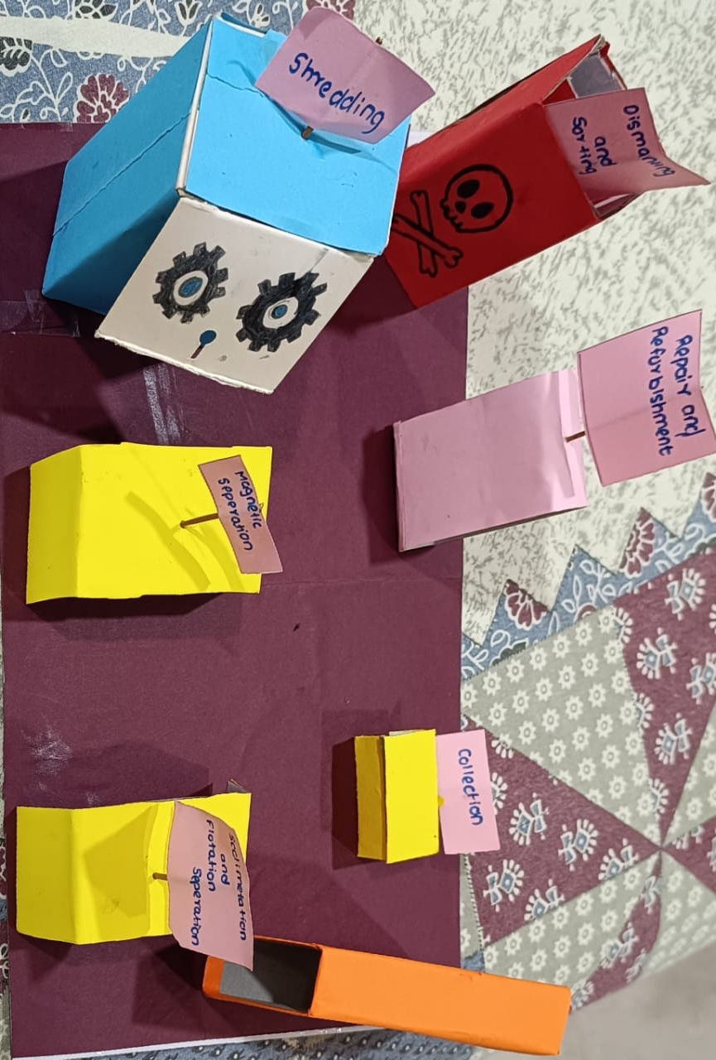

Step-by-Step Process of E-waste Recycling:

Recycling electronics is an often-challenging activity. This is because e-scraps are typically sophisticated and manufactured from diverse elements such as metals, plastics, and glass. While this process often varies, there is a general process.

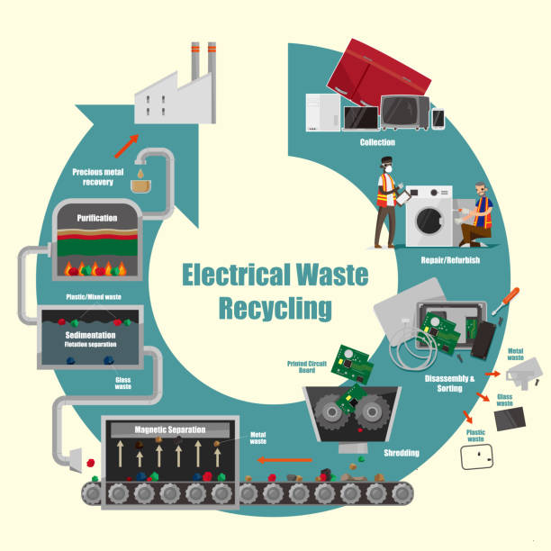

Step 1: Collection: This is the first stage of recycling e-waste. Here, recyclers place take-back booths or collection bins in specific places. When these bins get filled, the recyclers then transport the e-wastes to recycling facilities and plants.

Step 2: Repair and Refurbishment: Repairing an item is simply fixing the fault which has made it inoperable. It may also include some of the actions that are part of a refurbishment process. Refurbishment can include repairs, and should be done if needed, but is a lengthier process that includes cleaning, lubrication, oil changes, replacement of consumable items, doing a factory reset, doing cosmetic improvements, carrying out firmware upgrades, doing factory specified or in house recommended changes, replacement and/or upgrading capacitors, packaging the item for resale, along with any number of other actions.

Step 3: Dismantling and Sorting E-waste dismantling processes at Tec logic process is a mix of reuse and recycling of electronic waste through a mix of manual and automated process, bringing about zero environmental impact and maximizing value from the process of e-waste disposal. With the use of hands, these tiny prices get sorted and then manually dismantled. This is typically labour-intensive as waste items are, at this stage, separated to retrieve different parts.

Step 4: Shredding: As we all know, so much more personal and sensitive information is stored digitally every day. When it comes to identity theft and other crimes involving stolen information, computer hard drives are a big target. Unfortunately, all too often the disposal processes a facility might have for this electronic waste has not caught up with the sophisticated techniques of hackers and thieves. E-waste shredding will ensure that any information stored on hard drives or other device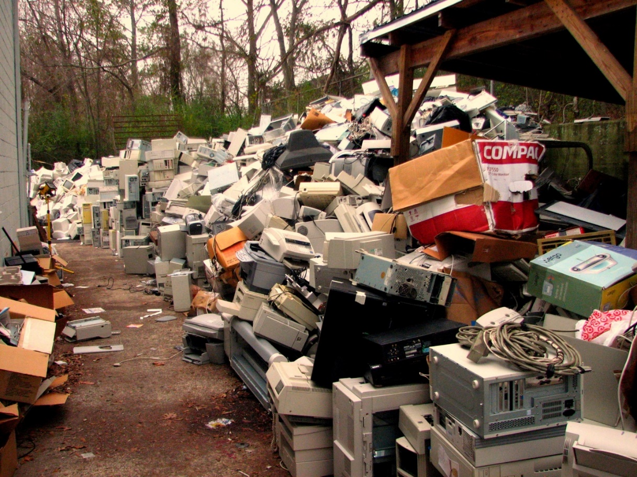s like phones and tablets is completely destroyed. It’s not enough to wipe the device and assume that the information is completely gone. E-waste shredding destroys items so hackers can’t use sophisticated equipment to retrieve it. Complete destruction of these devices can also help save office space. Many workplaces have old hard drives filling up a storage room and not being disposed of because they have sensitive information. Not only does that take up space, but it can also be at risk of being stolen.

Step 5: Magnetic Separation: After this, a strong overhead magnet helps you separate steel and iron from other wastes. This way, you have successfully recycled the steel from the waste stream. However, some mechanical processes may sometimes be required to separate circuit board, copper, and aluminium from other wastes particles. And this is especially where they are mostly plastic.

Step 6: Sedimentation and Flotation separation: Micro air bubbles are introduced into a flotation unit to remove substances from the water by means of flotation (uplift). This takes place by allowing the small air bubbles to adhere to the dirt, after which it floats to the top. The dirt or unwanted particles floating on top of the liquid is then removed with a scraper. And metals or wanted p

articles get sunk or settled at the bottom.

Step 7; Purification: After this huge long process, the next step is just to purify the wanted metals or to extract them in pure manner to reuse it or to sell it in the form of precious metals like gold, silver, platinum, copper, etc

.Chapter 4: Results and Discussion

1. *Pros and Cons*

There are both pros and cons of detoxing of toxic substance

Pros:

1. Benefits: Detoxifying could potentially reduce exposure to any trace chemicals or substances within computer components.
2. Environmental Concerns: It might reduce the environmental impact during the disposal phase if hazardous materials are properly managed.
3. Peace of Mind: It can give users peace of mind, knowing that their devices are as clean as possible.
4. Extended Lifespan: Cleaning and maintenance could extend the lifespan of computer components.
5. Improved Performance: Removing dust and debris may improve a computer's cooling and overall performance.
6. Data Security: Cleaning hardware could help protect sensitive data by preventing hardware failures.
7. Reduced Allergens: Cleaning can reduce allergens like dust, which is beneficial for users with allergies.
8. Aesthetics: A clean computer looks better and can be more pleasant to use.
9. Educational Opportunities: Detoxifying processes could be used to teach about environmental responsibility.
10. Consumer Demand: Some consumers may prefer eco-friendly products, leading to increased demand.

Cons:

1. Lack of Necessity: Most computers and related products don't emit toxins that require detoxification.
2. Expense: Detoxifying processes can be expensive, increasing the cost of products.
3. Complexity: It may be technically challenging to detoxify certain components effectively.
4. Environmental Impact: The detoxification process itself can have environmental consequences.
5. Resource Use: It may require additional resources like water and energy for cleaning processes.
6. Limited Benefit: The health benefits of detoxifying computer components may be minimal or negligible.
7. False Sense of Security: Users might think their devices are entirely toxin-free, which may not be the case.
8. Risk of Damage: Cleaning and maintenance can sometimes cause damage if not done properly.
9. Obsolete Technology: Detoxifying older computers may not be cost-effective if they are close to being replaced.
10. Regulatory Challenges: Compliance with environmental regulations and standards can be complex and costly.

*B) Relevancy of topic with green computing*

In an increasingly digital world, the environmental impact of computing technologies cannot be ignored. Green computing, which focuses on reducing the carbon footprint of IT systems, has gained significant attention in recent years. This paper explores the relevance of detoxing toxins using green computing practices. It delves into the environmental and health-related implications of toxic electronic waste (e-waste) and how sustainable computing can contribute to detoxification efforts. Throughout this discussion, we highlight the importance of integrating green computing principles into our technological landscape to mitigate the negative effects of toxins on both the environment and human health.

The digital revolution has ushered in an era of unprecedented connectivity, convenience, and information access. However, it has also brought about a significant environmental challenge - electronic waste (e-waste). E-waste is a global concern due to its toxic components and the rapid pace at which electronic devices become obsolete. Detoxifying the toxins present in e-waste is crucial for both environmental sustainability and human well-being. Green computing offers a promising avenue for addressing this challenge by reducing the environmental impact of IT systems and promoting sustainable practices.

E-Waste and Toxins

E-waste comprises discarded electronic devices such as computers, smartphones, and televisions. These devices contain a plethora of toxic substances, including lead, mercury, cadmium, and various flame retardants. When e-waste is improperly disposed of or incinerated, these toxins can leach into the environment, polluting soil, water, and air. Such contamination poses serious risks to ecosystems, wildlife, and human health.

**The Environmental Impact of E-Waste**

Detoxing toxins from e-waste is essential to mitigate the environmental impact. Green computing principles can contribute to this detoxification process in several ways:

1. Extended Product Lifespan: Designing electronic devices for longevity and ease of repair can reduce the rate at which they become obsolete. This approach, known as "planned obsolescence," can help in reducing the generation of e-waste.
2. Recycling and Proper Disposal: Encouraging the recycling of e-waste and the proper disposal of hazardous materials is a fundamental aspect of green computing. This ensures that valuable materials are reused, reducing the need for new resource extraction.
3. Energy Efficiency: Implementing energy-efficient technologies and practices in data centers and computing devices reduces their carbon footprint. This, in turn, decreases the environmental burden associated with the production and disposal of electronics.

**Human Health Implications**

The toxins found in e-waste not only harm the environment but also pose significant health risks to those exposed to them. Workers involved in e-waste recycling and informal disposal often face direct contact with hazardous materials. Additionally, communities living near e-waste recycling sites may suffer from air and water pollution, leading to various health issues.

Green computing can help detoxify toxins by minimizing the generation of e-waste and promoting responsible disposal. Longer-lasting devices reduce the frequency of disposal, thereby reducing the risks associated with toxin exposure. Moreover, improved energy efficiency in electronic devices and data centers reduces the energy demand of the IT sector, which, in turn, decreases the environmental pollutants associated with energy production.

Sustainable Computing Practices

To detoxify toxins from e-waste effectively, it is essential to incorporate sustainable computing practices into the design, manufacturing, and disposal of electronic devices. Some key strategies include:

1. Economy: Promote the adoption of a circular economy model where electronic components and materials are reused and recycled, reducing the need for virgin resources.
2. Design for Sustainability: Manufacturers should prioritize eco-friendly materials and designs that facilitate recycling and repair.

iii. Energy Efficiency: Continue to improve the energy efficiency of computing devices and data centers, reducing their overall environmental impact.

Detoxing toxins from electronic waste is a pressing environmental and health concern. Green computing provides a relevant and effective framework for addressing this issue by reducing the generation of e-waste, promoting responsible disposal, and minimizing the environmental impact of computing technologies. Integrating sustainable computing practices into the entire lifecycle of electronic devices is essential for detoxifying toxins, safeguarding the environment, and protecting human health. As we move forward in the digital age, it is imperative that we prioritize green computing to mitigate the toxic legacy of our electronic consumption.

CHAPTER 5: FUTURE ENHANCEMENT AND CONCLUSION

* Future Enhancement

1. Detoxification of toxins in green computing is a critical area of research and development as we strive to make our technology more environmentally friendly and sustainable. Here are some potential future enhancements and trends in this field:
2. **Advanced Materials and Nanotechnology**: Researchers are exploring the use of advanced materials and nanotechnology to create more efficient and environmentally friendly electronic components. Nanomaterials can help reduce the use of toxic materials and improve the recyclability of electronic devices
3. . **Biodegradable Electronics**: Developing electronic components and devices that are biodegradable is a significant trend. These electronics would break down naturally, reducing electronic waste. Materials like biodegradable polymers and paper-based circuits are already being explored.
4. **Toxicity-Reducing Manufacturing Processes**: Innovations in manufacturing processes can reduce the use of toxic chemicals and substances. This includes the adoption of cleaner production techniques, such as using supercritical CO2 as a solvent in semiconductor manufacturing
5. . **Energy-Efficient Computing**: Green computing isn't just about reducing toxins but also about improving energy efficiency. Developing more energy-efficient processors and data centres can reduce the overall environmental impact of computing
6. . **Circular Economy**: Implementing a circular economy approach in the electronics industry can help in detoxification. This involves designing products for longevity, repairability, and recycling. Companies are exploring take-back and recycling programs for their old products.
7. **Chemical-Free Cooling**: Traditional data centres require cooling systems that use toxic refrigerants. Future enhancements might involve the development of chemical-free cooling solutions, such as using phase-change materials or natural cooling methods.
8. **AI for Toxicity Detection**: Artificial intelligence and machine learning can be used to detect toxins in electronic waste more efficiently. AI algorithms can help sort and identify hazardous materials in e-waste streams
9. . **Regulatory and Policy Changes**: Governments and international bodies are likely to introduce stricter regulations regarding the use of toxic materials in electronics. Future enhancements may involve complying with and even exceeding these regulations to ensure greener computing
10. . **Consumer Awareness and Education**: Raising awareness among consumers about the environmental impact of electronics and the importance of responsible disposal and recycling is crucial. Future enhancements may involve more effective educational campaigns
11. . **Collaborative Research**: Collaboration between academia, industry, and government agencies will play a significant role in advancing detoxification efforts in green computing. Sharing research findings and best practices can accelerate progress
12. . **Incentives for Green Practices**: Governments and organizations may offer incentives, tax breaks, or subsidies for companies that adopt greener computing practices, including detoxification efforts.
13. **Blockchain for Supply Chain Transparency**: Blockchain technology can be used to create transparent supply chains for electronic components. This can help ensure that materials are sourced responsibly and that toxins are minimized throughout the manufacturing process.

Top of Form

Conclusion:

In the pursuit of green computing, detoxifying toxins is a critical step towards achieving a more sustainable and environmentally responsible technology industry. The significance of this endeavour cannot be overstated, as it directly impacts environmental preservation, human health, and resource conservation. By adopting detoxification strategies, such as Design for Environment, responsible recycling, the circular economy, and sustainable practices, we can detoxify the toxins associated with computing and pave the way for a greener, healthier, and more sustainable digital future. It is our collective responsibility to detoxify the toxins from our computing ecosystem and ensure that technology evolves hand in hand with environmental consciousness.

CHP 6 BIBLOGRAPHY

[1] Aditya Vijayvargiya and Mr. Kapil Sahu (2016), “E-Waste Technology”, International Journal of Engineering Research & Technology (IJERT), ISSN: 2278-0181, Vol. 4, Issue No. 32, <https://www.ijert.org/a-review-paper>on-e-waste-technology, Pp. 1-2.

2] Biswajit Saha(2014), “Green Computing”, vol. 14, number 2, Pp. 46-50.

[3] B.M. Gupta, S.M. Dhawan, Ashok Kumar and P. Visakhi (2018), “E-Waste Research: A Scientometric Assessment of Global Publications Output during 2007-16”, International Journal of Information Dissemination and Technology, ISSN (P): 2229-5984, ISSN (E): 2249-5576, Vol. 8, Issue No. 1, <https://www.proquest.com/openview/44fe7b15dfc6780e52cd46b97f72d5ce/1>? pgorigsite=gscholar&cbl=1036413, Pp. 31-36.

[4]Fazil Kaytez, Cengiz Taplamacioglu, Ertugrul Cam, and Firat Hardalac(2015),

“Forecasting electricity consumption: A comparison of regression analysis, neural

networks and least squares support vector machines”, vol. 67, Pp. 431-438.

[5]. Dr. Devika Rani Dhivya K, Aiswaryaa A.V and Shri Ram B (2023), “Green Computing Waste is a Terrible thing: Recycle”, International Journal of Scientific Development and Research (IJSDR), ISSN: 2455-2631, Vol. 8, Issue No. 2 <https://www.ijsdr.org/papers/IJSDR2302009.pdf>, , Pp. 48-51

[6] Govind Mishra and Venkat Ramanan(2014), “Journal of Energy Research and

Environmental Technology”, ISSN: 2394-1561, Pp. 4-36.

[7]Hitesh Monga (2018), “GREEN COMPUTING: APPROACHES AND ITS IMPLEMENTATIONS”, IJRAR- International Journal of Research and Analytical Reviews, ISSN (E): 2348 –1269, ISSN (P): 2349-5138, Vol. 5, Issue No. 3, <http://ijrar.com/upload_issue/ijrar_issue_1698.pdf>, Pp. 566-569.

[8]Jaskirat Kaur (2021), “GREEN COMPUTING – A LATE START”, International Research Journal of Engineering and Technology (IRJET), ISSN (E): 2395- 0056, ISSN (P): 2395-0072, Vol. 08, Issue No. 05, <https://www.irjet.net/archives/V8/i5/IRJET-V8I5431.pdf> . Pp. 2374-2377.

[9] J Patle, Raza, Khalid, V. K. Arya, Sandeep(2012), “A Review on Green

Computing for Eco-Friendly and Sustainable IT”, Vol. 1, number 1, Pp. 3-16.

[10]Krati Banal, Pratik J. Kurle and Priyanka Chawla (2015), “Green Computing an approach towards a healthier environment”, International Journal of Computer & Organization Trends, ISSN: 2249-2593, Vol. 5, Issue No. 6, Pp. 9-13. <https://ijcotjournal.org/asserts/year/2015/volume-27/number-1/IJCOT>V27P302.pdf , Pp. 9-13.

[11] Navjot Kaur and Gagandeep Singh (2016), “Review on Green Computing: The next movement in computing”, International Journal of Advanced Research in Computer and Communication Engineering, ISSN (O): 2278-1021, ISSN (P): 2319 5940, <https://www.ijarcce.com/upload/2016/april>16/IJARCCE%20267.pdf , Pp. 9-13.

[12] Dr. Neha Garg and Deepak Kumar Adhana (2019), “E-WASTE MANAGEMENT IN INDIA: A STUDY OF CURRENT SCENARIO”, International Journal of Management, Technology and Engineering, ISSN: 2249-7455, Vol. 9, Issue P a g e | 52 TOXICITY No.1, <https://papers.ssrn.com/sol3/papers.cfm?abstract_id=3356877>. ,Pp.2791-2803

[13] Peeranart Kiddee, Ravi Naidu and Ming H. Wong (2013), “Electronic waste management approaches: An overview”, International Journal of Integrated Waste Management, Science and Technology, ISSN 0956-053X, Vol. 33, Issue No.5. <https://www.nqr.gov.in/sites/default/files/File%202_waste%20mgt.pdf>. Pp.1237-1250

[14] Pijush Kanti Dutta Pramanik, Saurabh Pal and Prasenjit Choudhury(2019),

“Green and Sustainable High-Performance Computing with Smartphone Crowd

Computing”, Vol. 20, number 2

[15]Richa Pandey, Kavita Rawat, Komal Kirola and Lalit Mohan (2017), “THE RISING ERA OF GREEN COMPUTING”, International Journal of Computer Science and Mobile Computing, ISSN: 2320–088X, Vol. 6, Issue No.2<https://www.ijcsmc.com/docs/papers/February2017/V6I2201729.pdf> . Pp. 127-130

[16] Santosh Kumar (2017), “Green Computing”, IJSR - International Journal of Scientific Research, ISSN: 2277 – 8179, Vol. 4, Issue No. 2, Pp. 67-69. <https://www.worldwidejournals.com/international-journal-of-scientific-research>- (IJSR)/article/green-computing/NDgxMQ==/?is=1, Pp. 67-69.

[17] Ms. Simmi Chawla and Mr. Tarun Dalal, “Challenges and proposed solutions in order to achieve green computing”, International Research Journal of Engineering and Technology (IRJET), ISSN (E): 2395 -0056, ISSN (P): 2395- 0072,Vol.04,IssueNo.04. <https://www.irjet.net/archives/V4/i4/IRJET-V4I4883.pdf>. Pp.3657-3663

[19]Vanthana. N (2018), “Green Computing”, International Journal of Engineering Research & Technology (IJERT), ISSN: 2278-0181, Vol. 06, Issue No. 07, <https://www.ijert.org/green-computing> . , Pp. 1-5.

[20].Veenaa Deeve, N.V., Vijesh Joe and Namratha (2015), “RESEARCH ARTICLE STUDY ON BENEFITS OF GREEN COMPUTING”, International Journal of Current Research, ISSN: 0975-833X, Vol. 07 Issue No. 04<https://www.journalcra.com/article/study-benefits-green-computin>g. , Pp. 14443-14445.

REFERENCE BOOK

* Green IT By Toby VeLte, Anthony Velte and Robert Elsenpeter
* Green Technology